DAY 3 TASK

- COMPARE THE TWO JSON HAVE THE SAME PROPERTIES WITHOUT ORDER

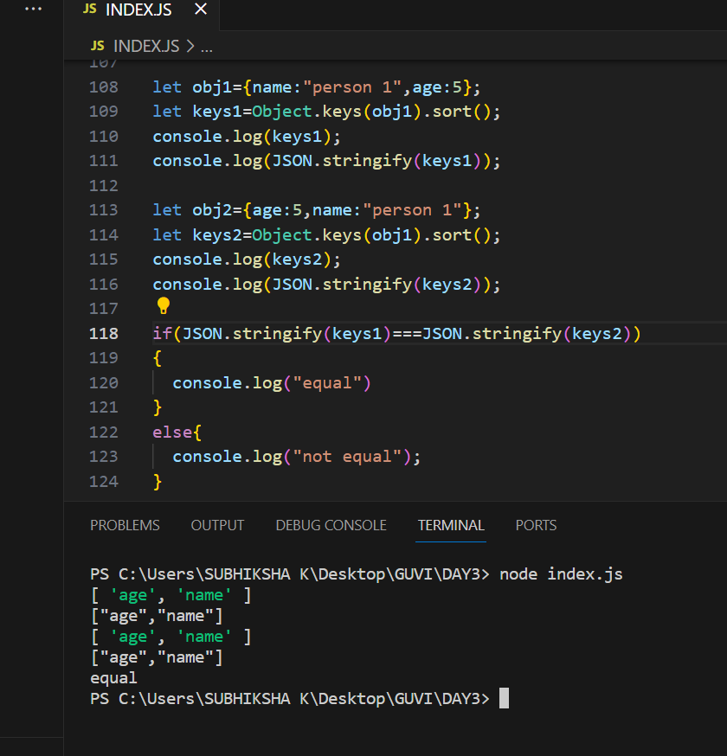

2)USE THE REST COUNTRIES URL https://restcountries.com/v3.1/all
PRIINT THE FLAGS IN THE CONSOLE.

PROGRAM

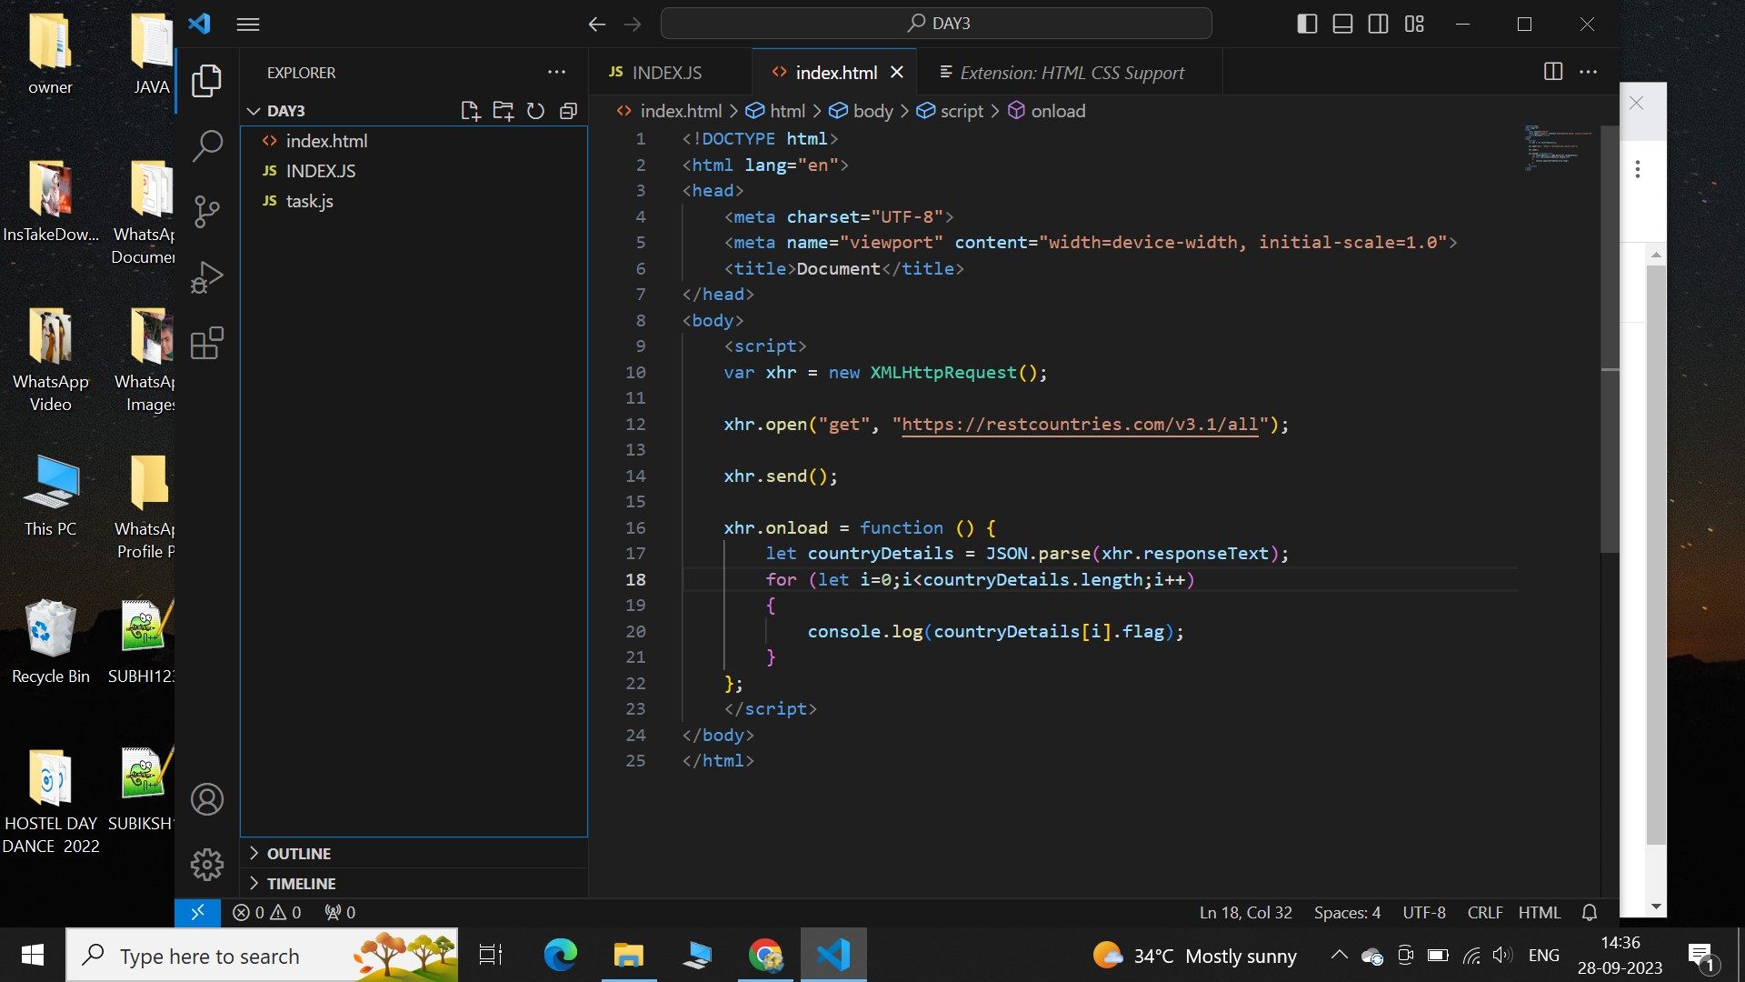

OUTPUT

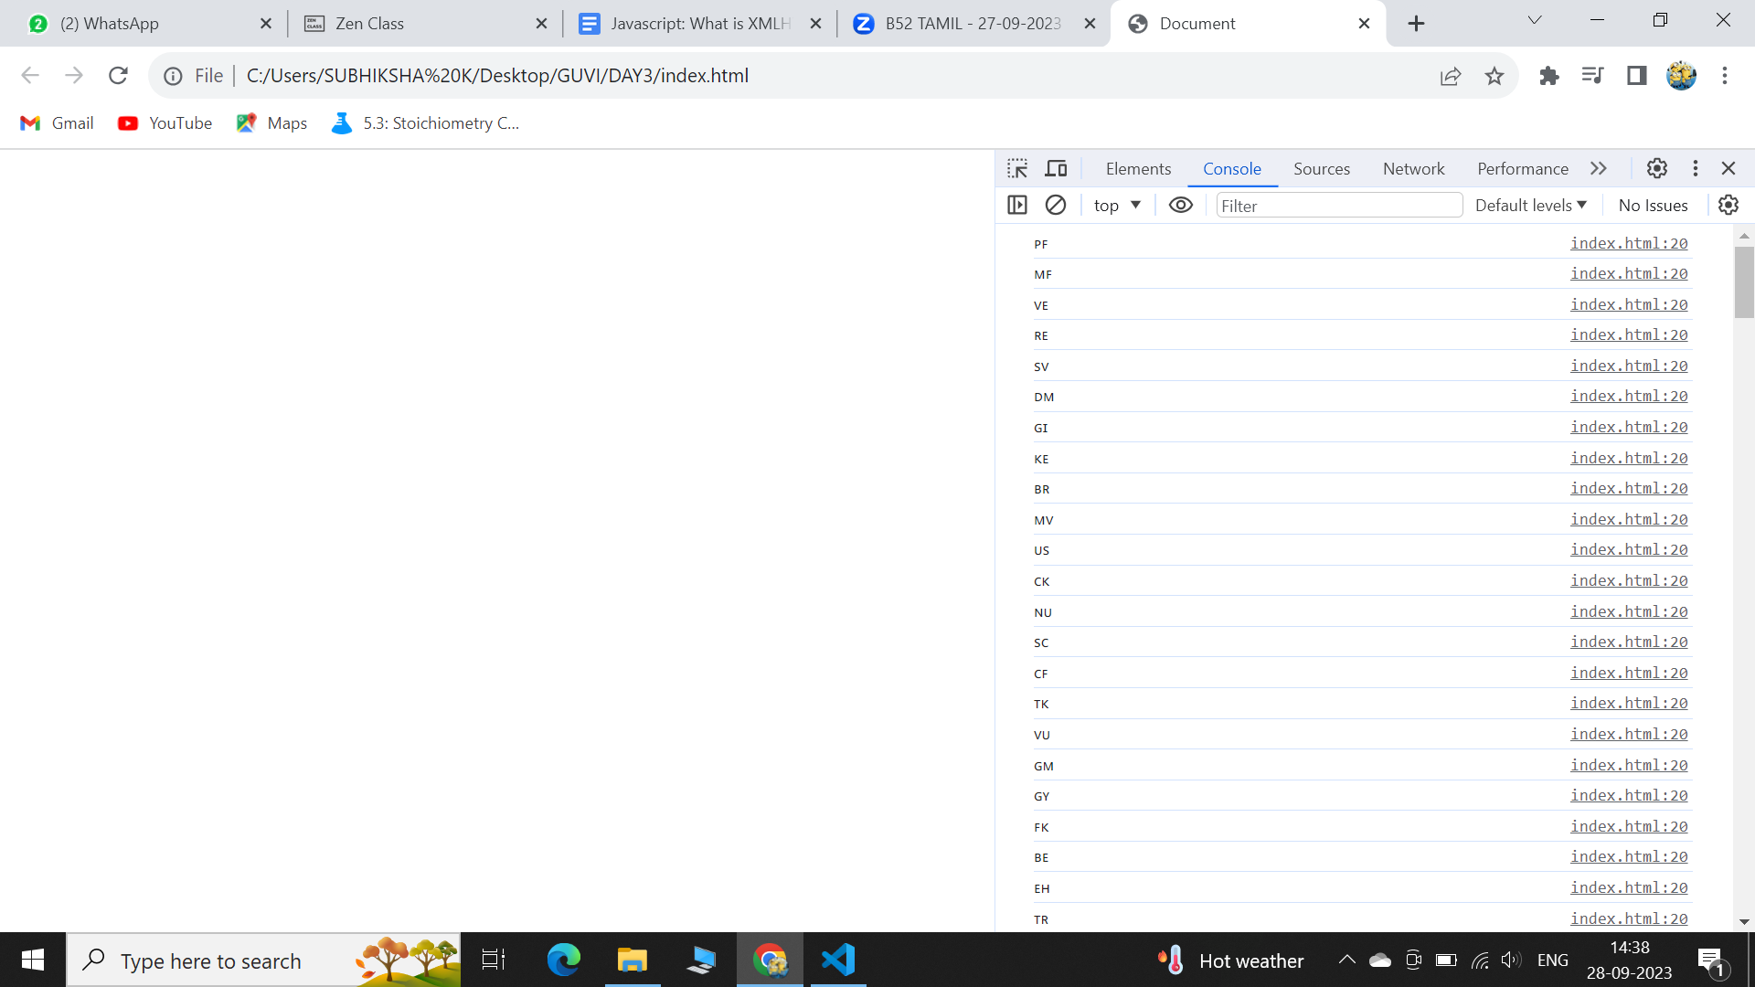

USE THE SAME URL AND PRINT THE COUNTRY NAME,REGION,SUBREGION,POPULATION.

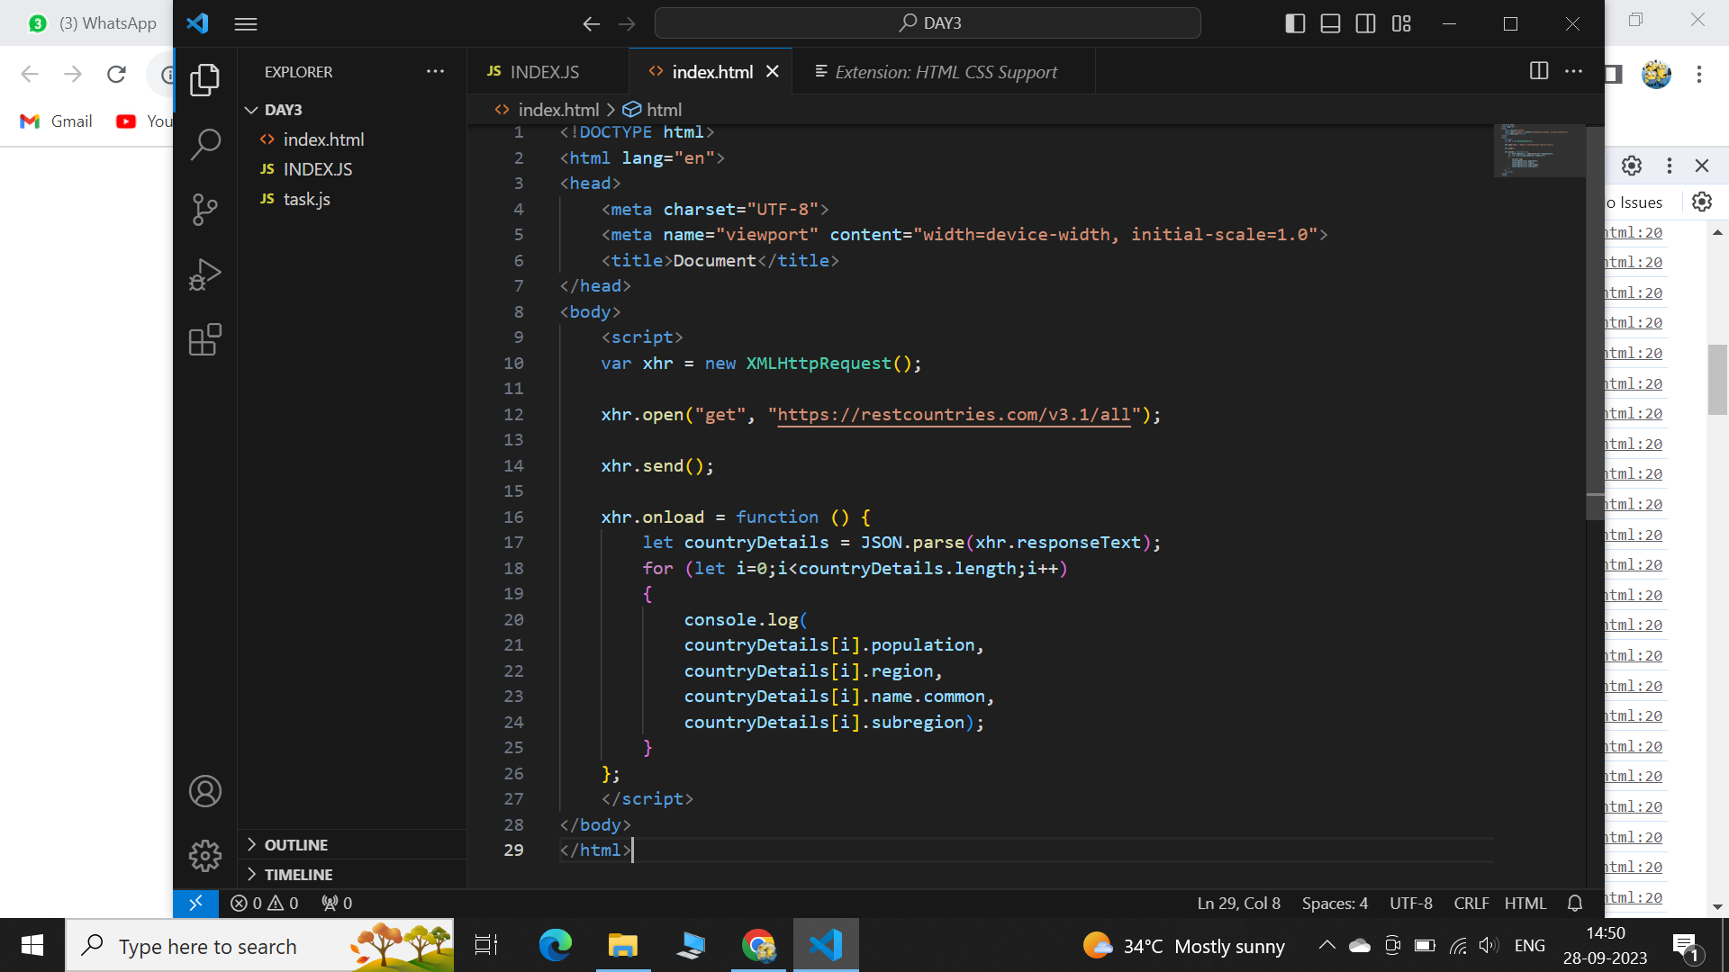

OUTPUT